Implementing and Managing Institutional External Landing Pages Hosted by iLab

Overview
Options for the Institution Landing Page
Institution About Tab
How to Setup Your Institution External Landing Page
Display Options for External Landing Pages
Core, Service, and Equipment Visibility Settings for External Landing Pages
Ability to Add Descriptions to Cores on External Landing Pages
Ability to Add Information about Institutional Cores not in iLab
Additional enhancements and features within Search settings tab
Core facility service classifications
Show browse by classification bar
Display the Category filter panel in the Search page
Display the Category name within a search result
By default, display filters panel and results section on Search tab
Adding classifications to services and equipment

Overview
iLab offers and hosts publicly facing and searchable core landing pages. This
allows the core to market themselves to potential users without the user having to log into iLab.
Customers with institute-wide deployments expressed an interest in an institution level
homepage as well. To meet this request, iLab has designed a robust institution landing page
that will be simple to use but still meets the high-level goals of our clients. The main goal of this
page is to make it easier for core users to find the facility or services they are looking for without
having to log into iLab. This creates opportunity to serve more core customers and raise core
usage.

The institution landing page will be tailored for and by institution administration. On this page,
administration can do the following:
● Add announcements, updates, and general information
● Edit content, font, header color, and tab name
● Designate automatically updated information, which is pulled from within the system, i.e.,
changes in services offered*
● Select to list all their cores that use iLab and a search for their services**

*We kept in mind that some facilities, services, and pricing may not be okay to share publicly and
have allowed facility management to determine what can be seen on this public facing landing
page. The services, content and even pricing will be managed by core management on a per
service/resource basis, but anything pertaining to the service that is deemed to be publicly
available can be available through the institution services search.

**Core administration can decide if they would like their specific core listed once institution
administration turns on the setting to list all cores on the institution landing page.
Please read on for more information.

Options for the Institution Landing Page

Institution About Tab
On the institution landing page, the homepage or “About” tab will have a single formattable text box that institution administration can edit and update as needed. Content, font header, color and tab name can be modified by institution administration.
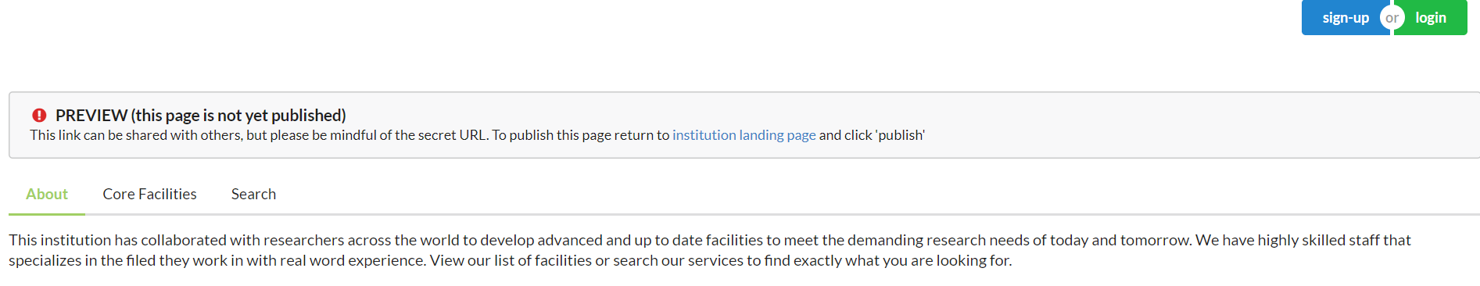

Institution Core Facilities List Tab
Institution administration can choose to list core facilities that are currently set up in iLab. This list will live on the institution cores tab and will update automatically with each new core added. The simple browse view of this list allows potential customers to click on the core’s name and navigate to that core’s landing page to find out more about the facility.
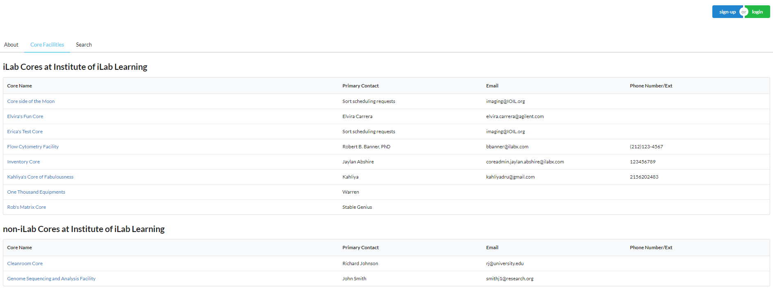

Institution Search Services Tab
To make it easier for future customers to find the core, institution administration can choose to show a services search tab. Services, content, and pricing available will be managed by the core on a per service/resource basis. Anything pertaining to the service that is deemed to be publicly available is searchable through the institution services search. Users can navigate directly to the specific core that provides the service from the search results.
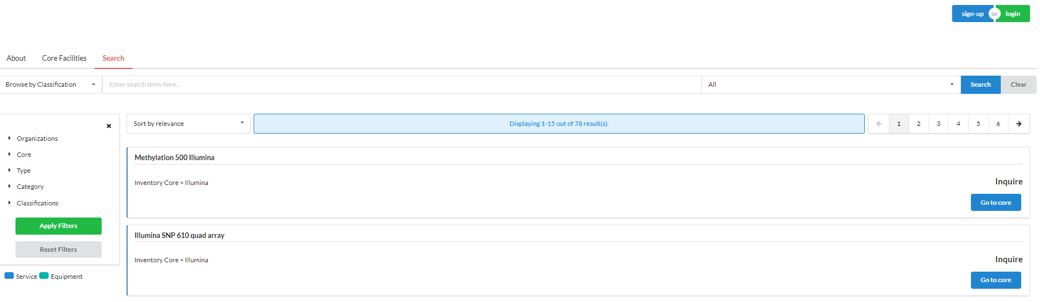

Your Institution External Landing Page
To access your institution page, click on the name of your institution on the left-hand side of your iLab page.
- After logging into iLab, click on the hamburger symbol (three horizontal lines on top left side of your screen).
- Click on your institution name
- Click on Settings.
- On this tab, you will work within these sections: Landing Page, Non-iLab Cores, Cores Landing Description, and Landing Page Settings.
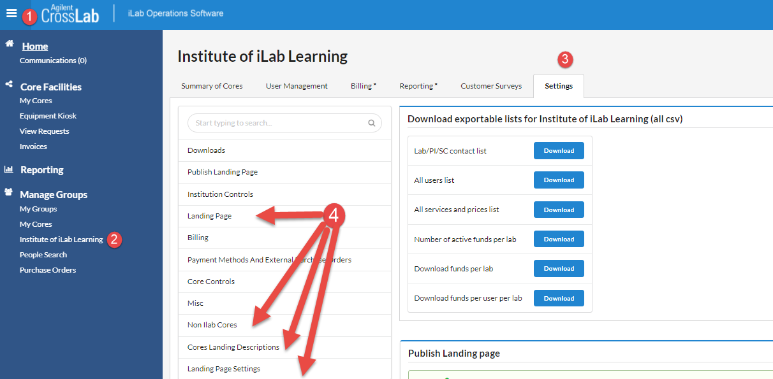

Landing Page: Allows settings (i.e., display non-iLab cores to display on external page, manage descriptions of cores using iLab to display on external page, etc.) to be enabled to appear on the landing page as well as change the display name of tabs as well as the color of the tabs.

  - The landing page will automatically have an About tab that you can add formatted text, images, and video to, but you may also want to show a list of institution cores and let users search for services.
  - To display the tab that contains a list of cores to choose Activate 'cores' tab on landing page.
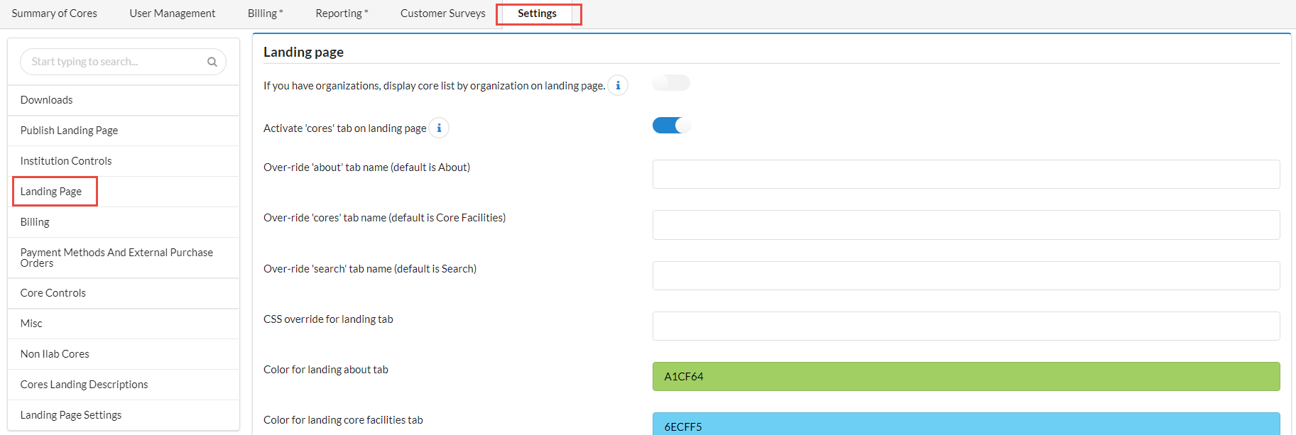
  - After choosing to show the Core Facilities tab (or list of all cores) to users on the external landing page, you can choose to also show them a search page where they can search for services and resources that your facilities provide.
  - If your institution has multiple administrative groups, (Organizations in iLab), that manage different core facilities, you can group the list of facilities on the cores facilities tab by organization and display the specific organization logo.
The next set of settings will help you make the institution landing page unique for your institution.
- The About, Core Facilities, and Search tabs already have default names, you can adjust the names to be more specific for your institution. There is a maximum of 40 characters for each tab name.
- The next setting filed lets you adjust some CSS formatting.
    - We recommend that users with HTML experience update the CSS elements.
    - You can also select the color of the tab by inserting the color number into the tab color field.
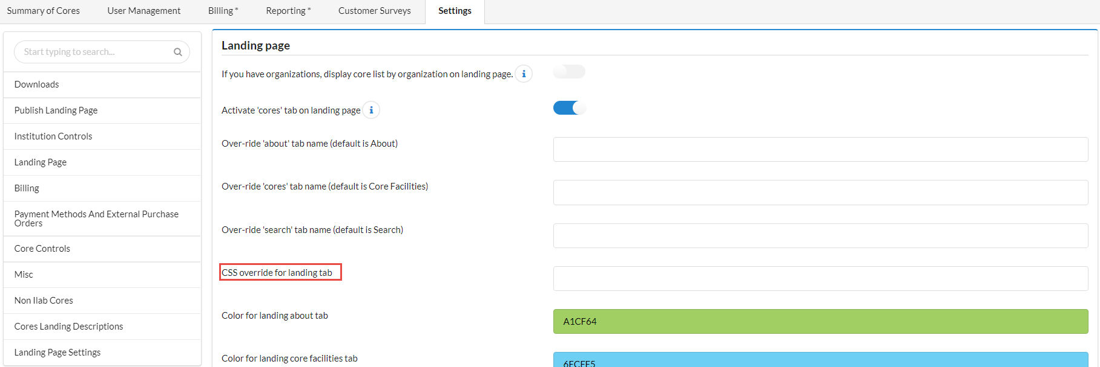

Non iLab Cores: This setting must be enabled from the Landing page section, under Do you want to display non-iLab cores on your external core facilities page?
Once this setting is turned on, you will see the option to add a core display at the bottom under Manage Non iLab Cores of the Settings page that allows you to manually enter the following information:
- Name of Core (required field)
- Hyperlink to a Core web page (required field)
- Primary Contact (required field)
- The Core’s Contact Number

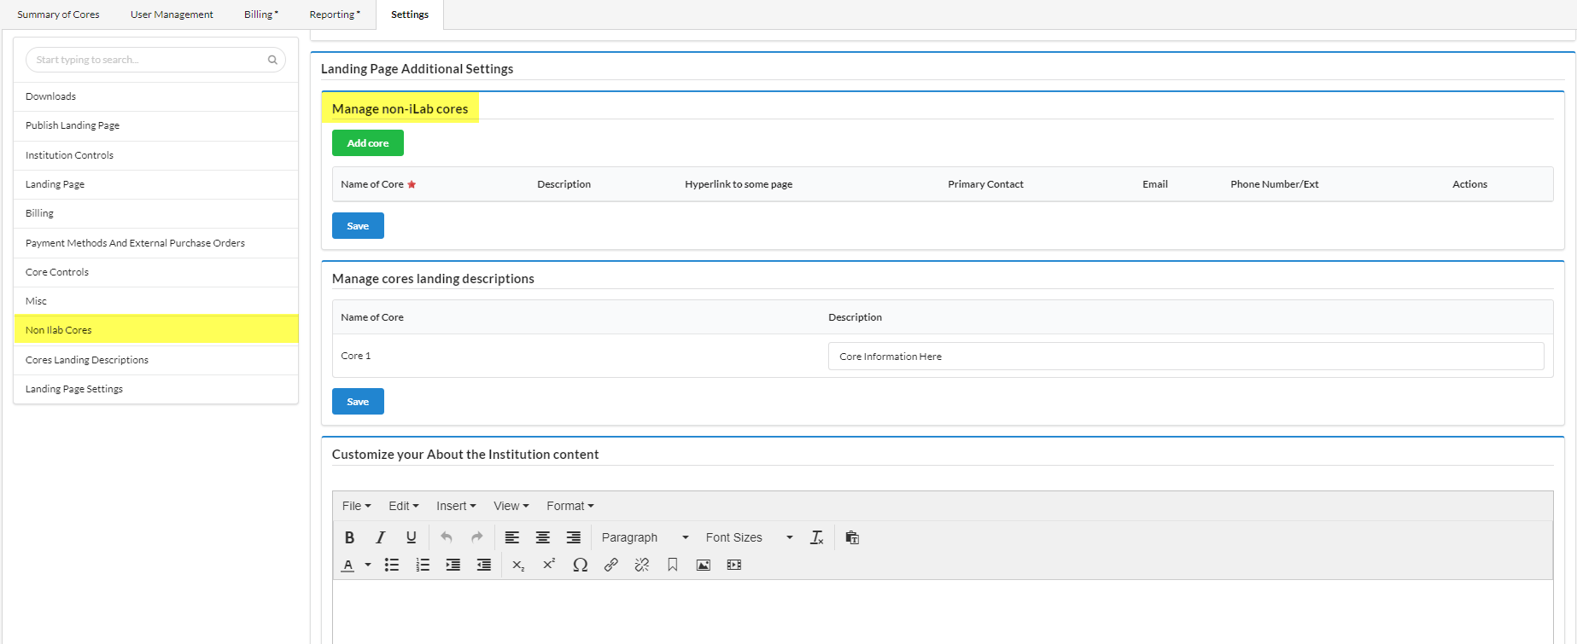

Core Landing Description: Once this setting is turned on, you will see a list called Manage cores landing descriptions display at the bottom of the Settings page. This table will be auto populated with a list of institutional cores. Once a description has been entered, click Save. These descriptions will now be listed under each core’s name on the institutional external landing page, within the Core Facilities tab.

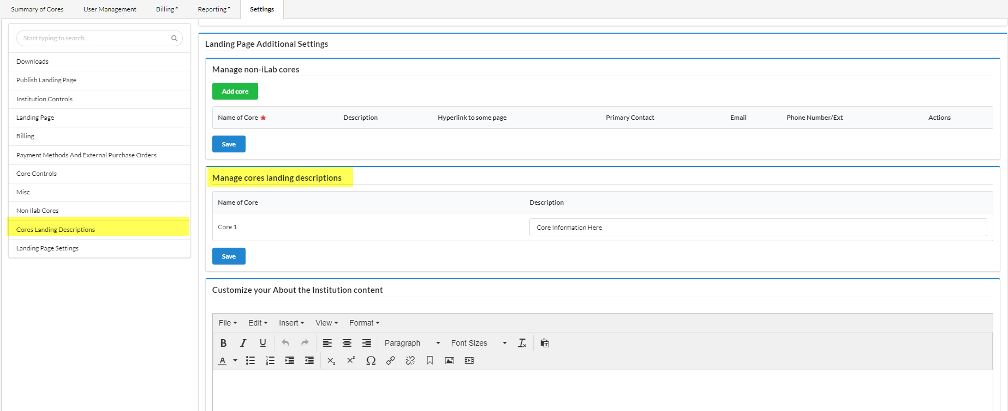
Landing Page Settings: This section is to update the content on the institution landing page About tab. This is the section, where you can add any information, you would like to display. Please note:
- The institution logo at the upper left is determine by the logo that was added on the institution setting tab.
- Any images and videos you add, should use a https:// URL so as not to cause problems with user security firewalls.
- Font type and style is determined by the CSS formatting above.
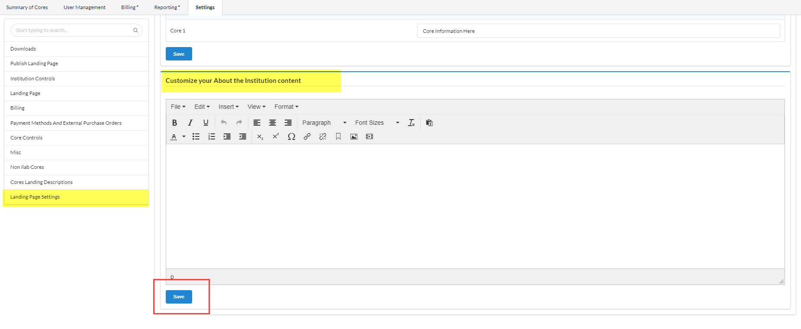

Note: To view any changes made to the landing page. You will want to select Publish Landing page from left side of screen or scroll to the section. (1) Right click on ‘here’ and open in incognito page to view the changes you have made. (2) You will not want to click on ‘Publish’ as the landing page should not be published until the in site is in production.
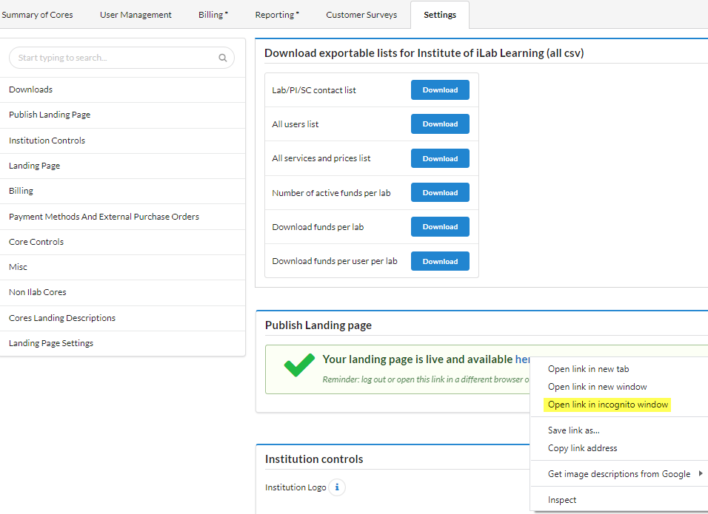

Display Options for External Landing Pages
Core, Service, and Equipment Visibility Settings for External Landing Pages: The information for services and resources that can be seen on the Institution Landing page is controlled by each facility. The facility can choose if they want their core listed on external pages by adjusting landing page settings on the Core’s Administration tab. Core administrators can choose what services and resources are available on the landing page search tab. They can also select which pricing shows and if a user can view a read-only schedule before log in.

To see more information about core service and resource scheduling visibility on external
pages, please click here

Ability to Add Descriptions to Cores on External Landing Pages: Institution administrators have the ability to add core descriptions and list facilities not currently using iLab to the external landing page. To activate this functionality, navigate to the Institution Settings Tab > Landing Page > Display core facility descriptions within Core Facilities tab?

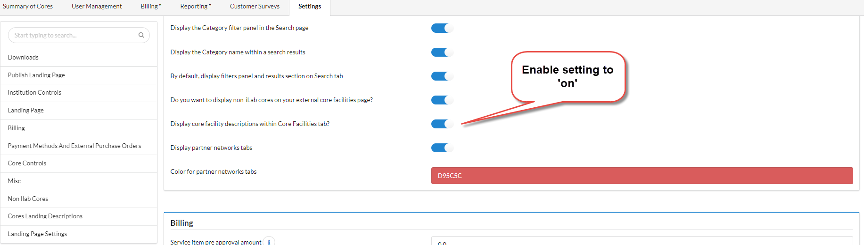

Once this setting is turned on, you will see the core names and text box under Manage cores landing descriptions. This table will be auto populated with a list of cores at the institution.
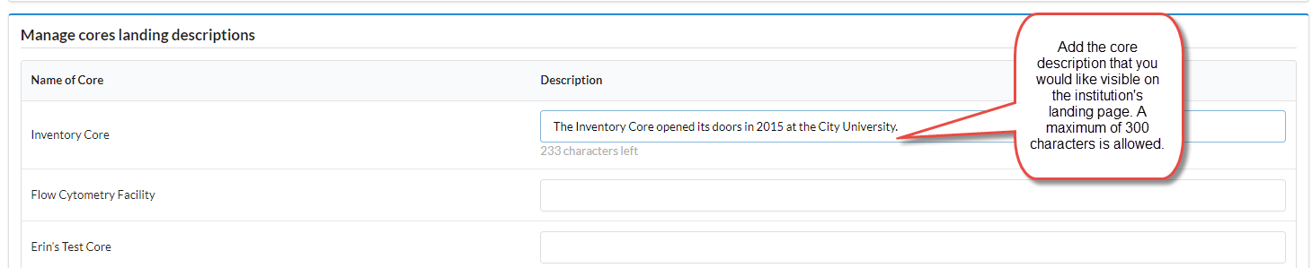

Each core has a free text Description box that can accommodate up to 300 characters of text.
Once a description has been entered, click Save. These descriptions will now be listed under
each core’s name on the institutional external landing page, within the Core Facilities tab.

Ability to Add Information on Institution’s non iLab Cores: To activate this functionality, navigate to your Institution Settings Tab > Landing Page> Do you want to display non-iLab cores on your external core facilities page?
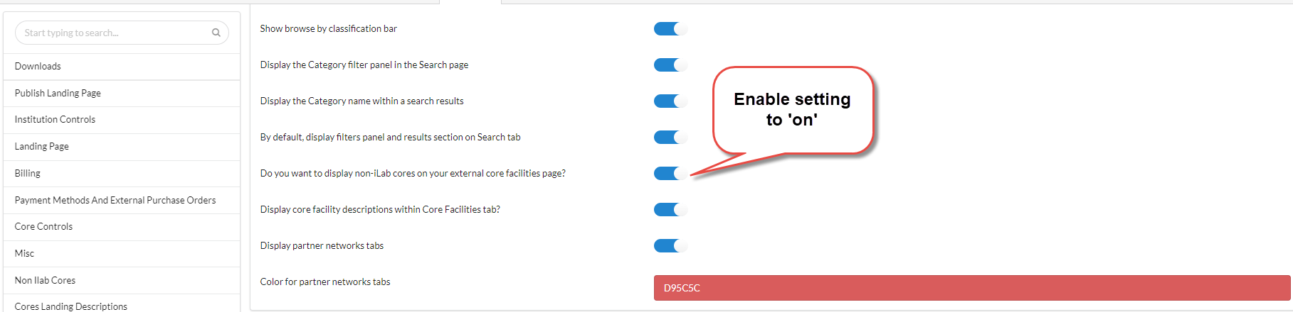

Once this setting is turned on, you will see text boxes display at under Manage non-iLab Cores, to manually enter the following information:
1. Name of Core (required field)
2. Description of Core
3. Hyperlink to a Core web page
3. Primary Contact
4. The Core’s Contact Email Address
5. The Core’s Contact Telephone Number

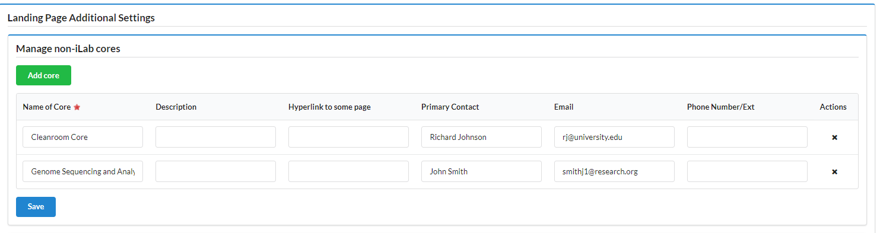

Additional Enhancements and Features within Search Settings Tab
Core facility service classifications
​To provide a universal and standardized seed set of Classification terms for core facilities to tag their services and equipment, iLab has chosen to use the eagle-i ontology data set. Classifications within iLab are different than the existing iLab “categories”. Categories are typically used to group services and equipment into topical areas that may be configured directly by the core.

There are several settings within the Landing Page section of Settings that relate to the
way categories and classifications may be displayed within an external landing page Search
tab:

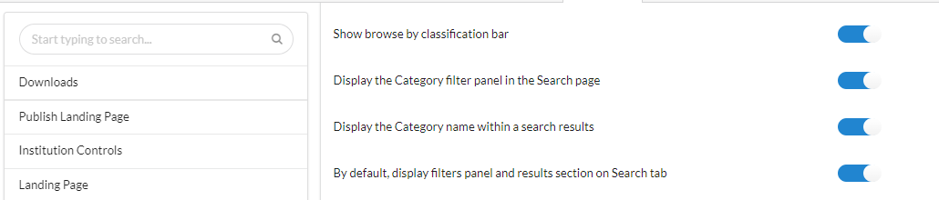

Show browse by classification bar
This setting controls whether the Browse Category drop-down menu displays as part of
the Search bar. This drop-down menu displays high-level classification terms frequently
searched for and are manually selected by an iLab data curator for display. A user can also
hover over one of these higher-level classification groupings to see individual search terms
associated with those groupings that have been used by a core to classify a service or piece of
equipment. The order in which those individual terms are listed is determined by the
frequency in which those terms have been used for classification of services or equipment by
core facilities.

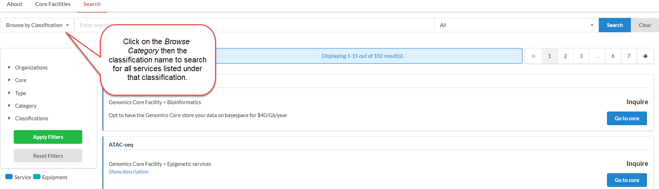

Display the Category filter panel in the Search page
This setting controls whether a Category filter panel displays in the Search page.
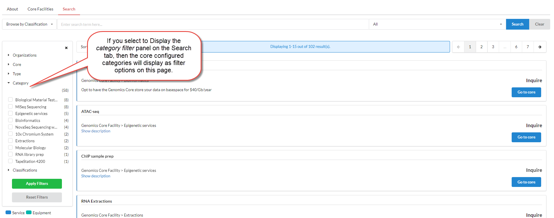

Display the Category name within a search result
This setting controls whether Category labels display within an individual search result. If
a service or piece of equipment has been tagged with a classification, that classification will
always be displayed.
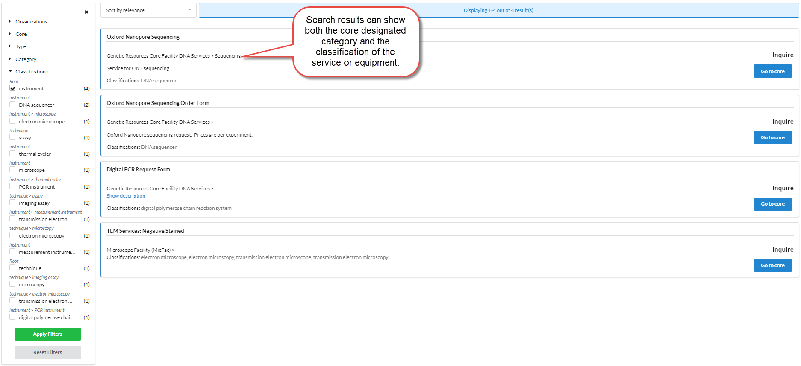

By default, display filters panel and results section on Search tab
This setting controls whether filter panels and a search results section automatically
display when a user first lands on the Search tab. If this setting is enabled, all services and
equipment available at that institution will be displayed by default.
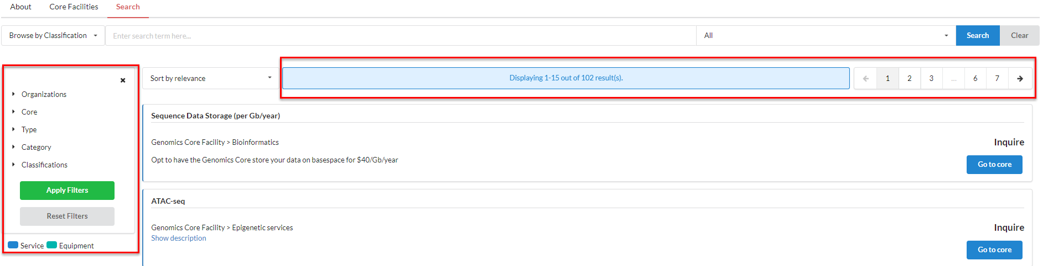

If this setting is not enabled, the user will first be presented with a simple search bar and no initial content on the page:

Adding classifications to services and equipment
Adding classifications to services, service project templates and equipment is done at the
individual core facility level and is managed by a core facility administrator. Adding
classifications are performed within the service; service project or equipment edit pages. Below is
an example from an edit service page.
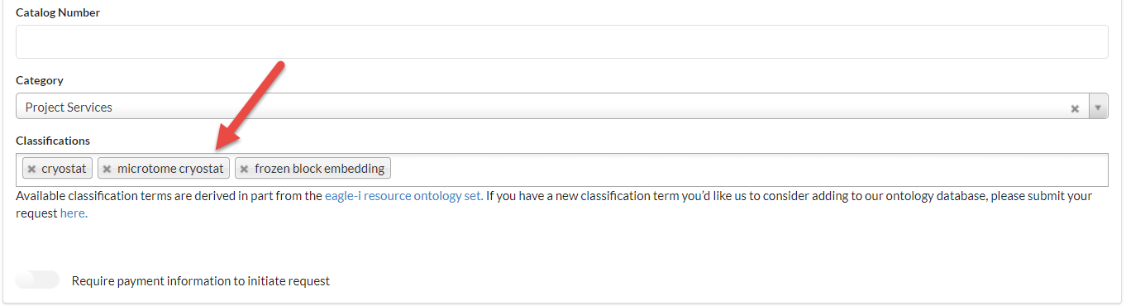

The Classifications section allows a core administrator to do a search of the existing
classification terms in iLab to tag their services, service project or equipment with. Multiple
classifications may be added. In addition if there is a search term a user may feel is missing
from the ontology database, they may submit a request to have a new term or synonym
of an existing term added to the iLab classification dataset​. There is a hyperlink below the
Classifications section that will direct the user to the classification term/synonym request form.

When a classification term has been added to a service or an instrument, there will be a visual
indicator next to the name of each entity in the core’s list of services or equipment that, when
hovered over, will display all linked classifications. This informational icon will be visible to users
that are logged in to iLab.

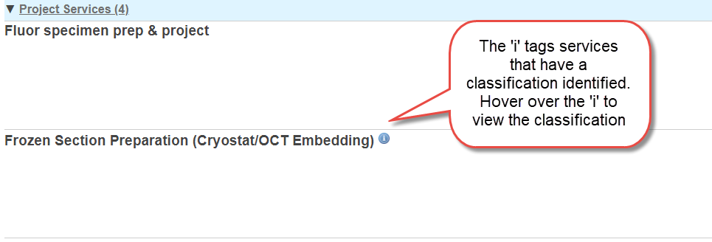

For more information, please reach out to your iLab representative or contact us at ilab-support@agilent.com

